AWS Architecture for 3 Tier Applications
Login to AWS
Step 1:
Create a VPC
Search for VPC
VPC IP – 10.0.0.0/16
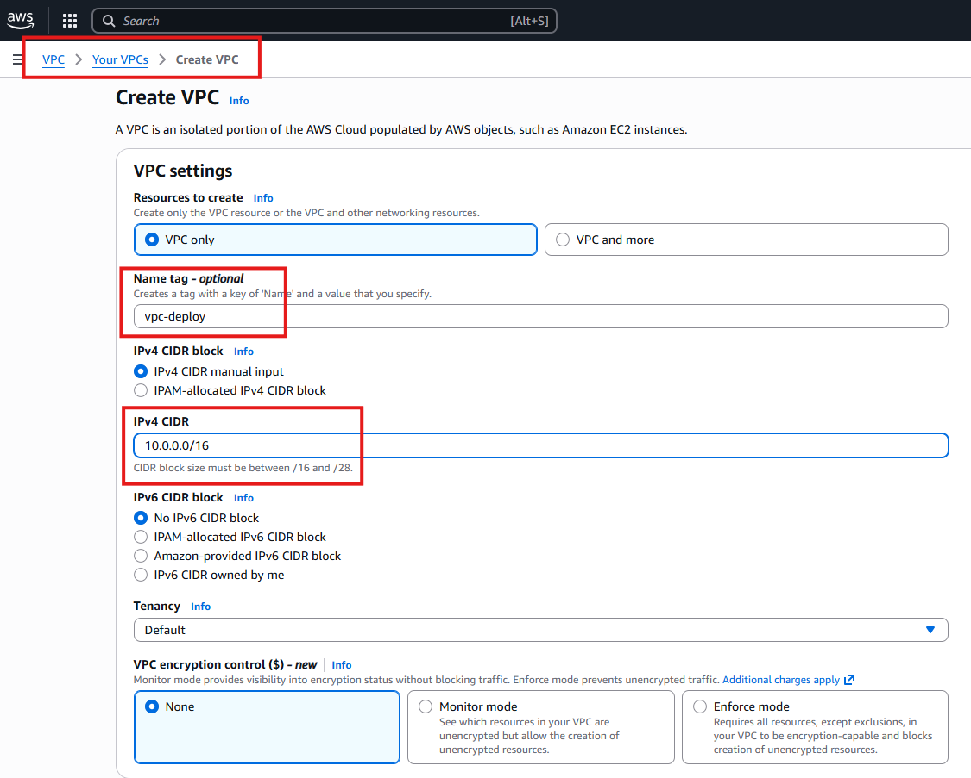
After creating a VPC, we will add 2 subnet under VPC i.e Private and Public
Step 2:
Public Subnet – 10.0.2.0/24
Private Subnet – 10.0.3.0/24

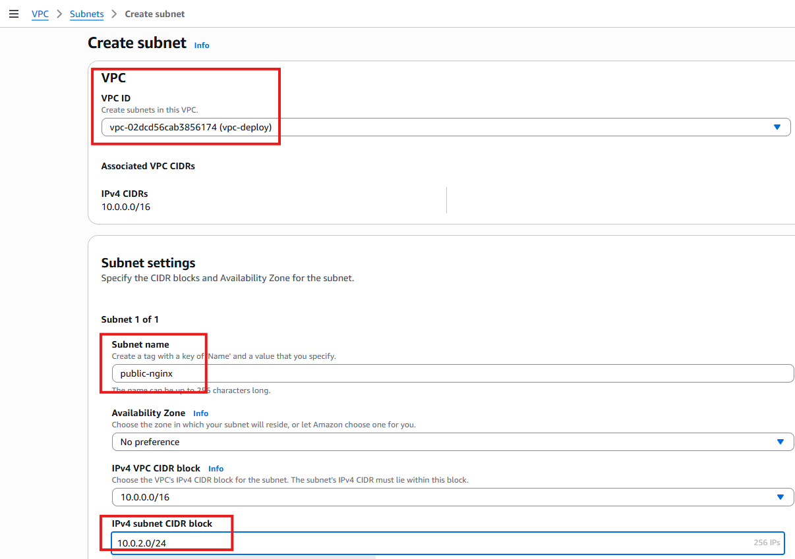

2nd Subnet
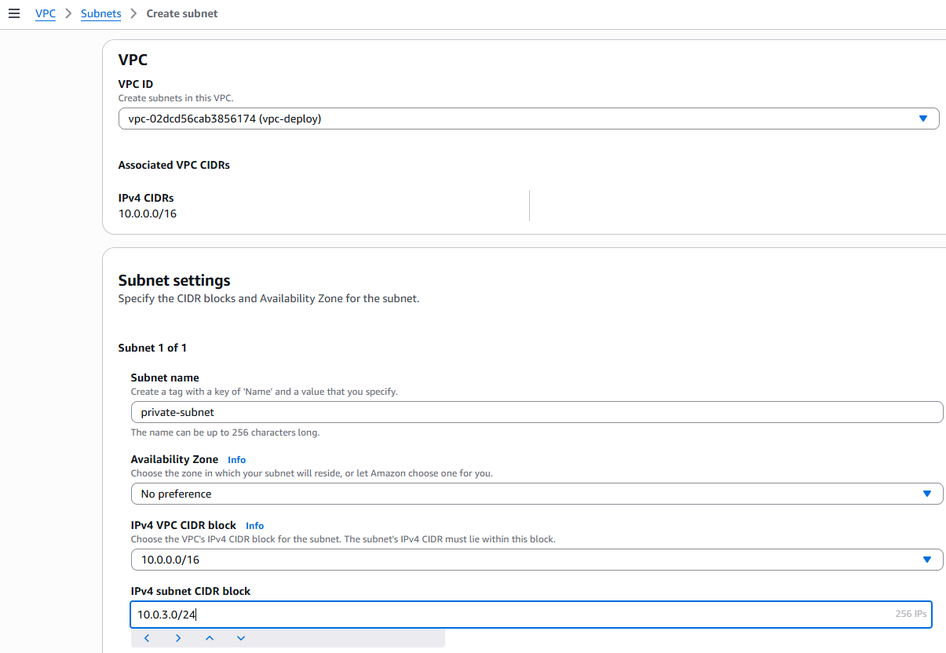

Launch a ec2 Instance for Nginx , appserver and database server
Nginx will be under public subnet
App server and Database server is in private subnet

Select VPC and Subnet settings in Networking while creation time

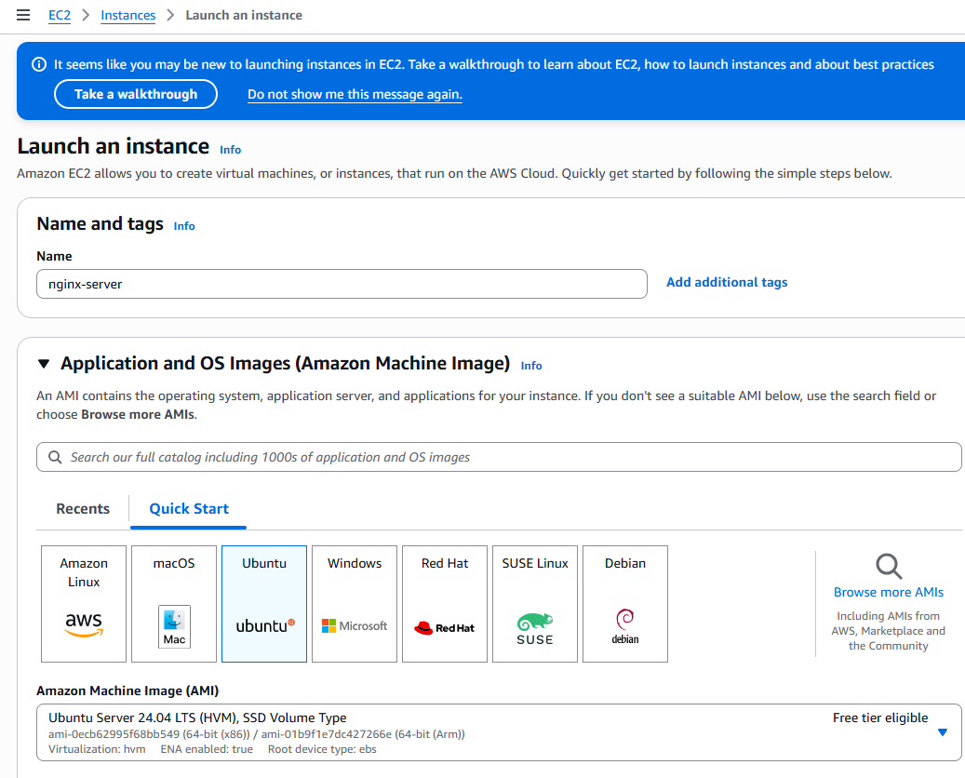

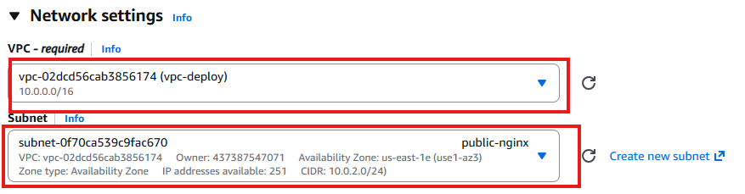

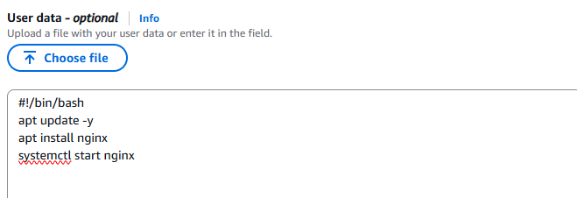

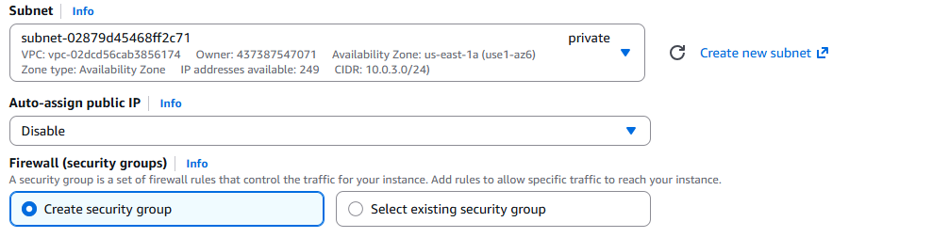

After completion of the Nginx, App server and Database server, Create a NAT Gateway and attached to VPC

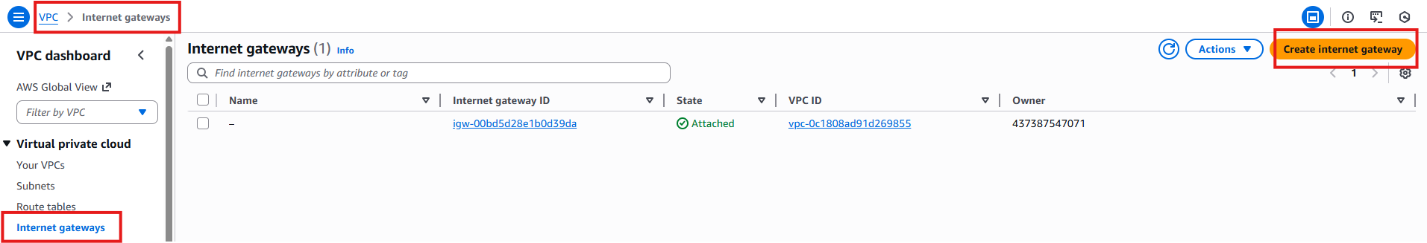

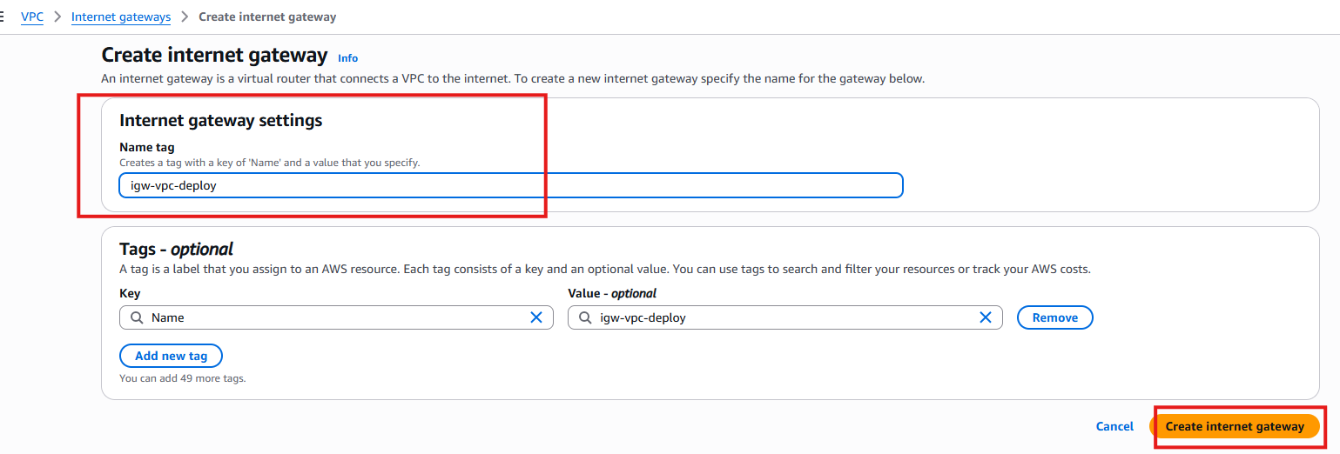

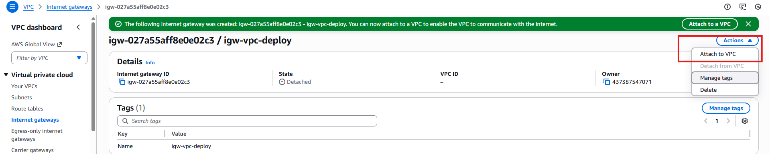

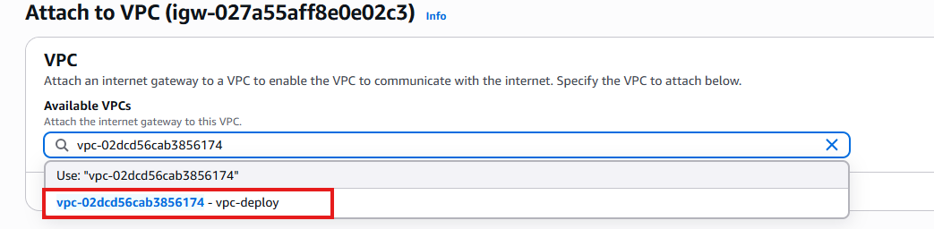

Open port in Security Groups
For Nginx – 80
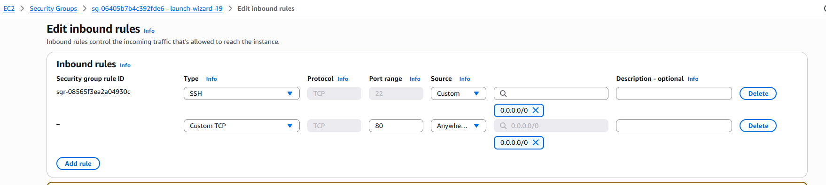
For Database – 3306
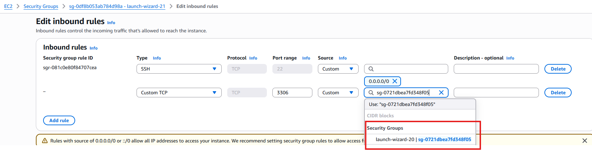
I just allowed app server to connect to database, so I assigned app server security group id (from 3000 to 3306)

For Appserver 3000
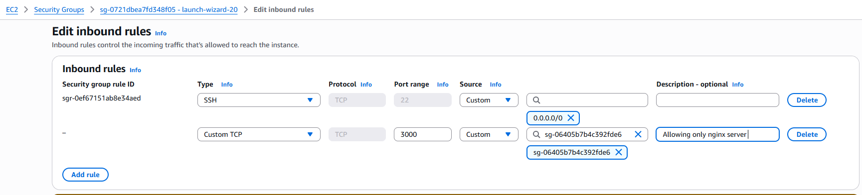
I allowed only nginx server to connect my app serever (from 80 to 3000)

Create Route table
Bydefault the traffic client request will not reach to nginx server from internet gateway, vpc
We have to allow traffic to come-in via route table, and associate it with public subnet
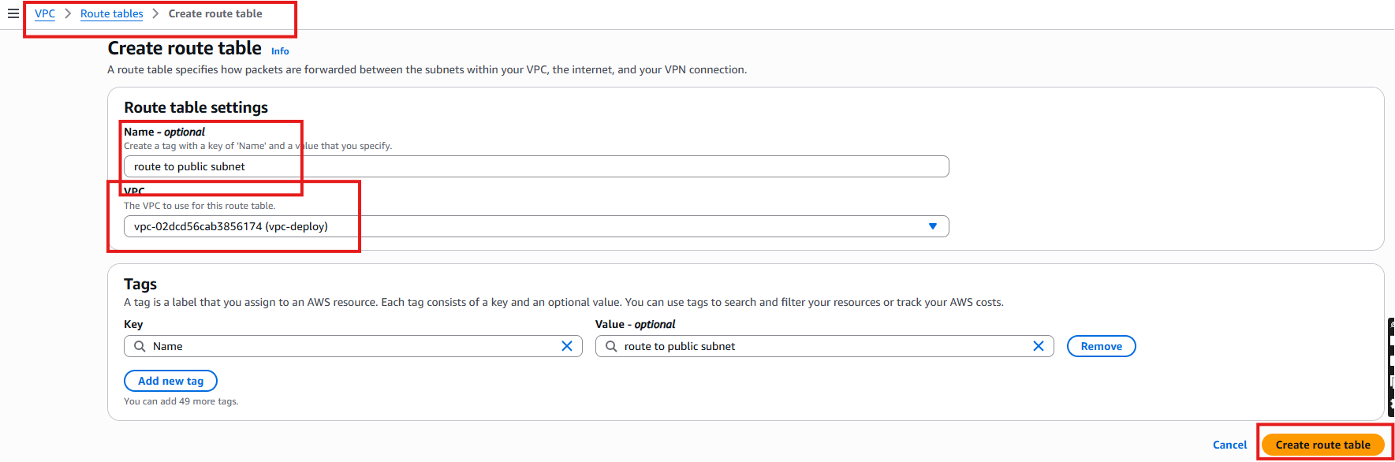

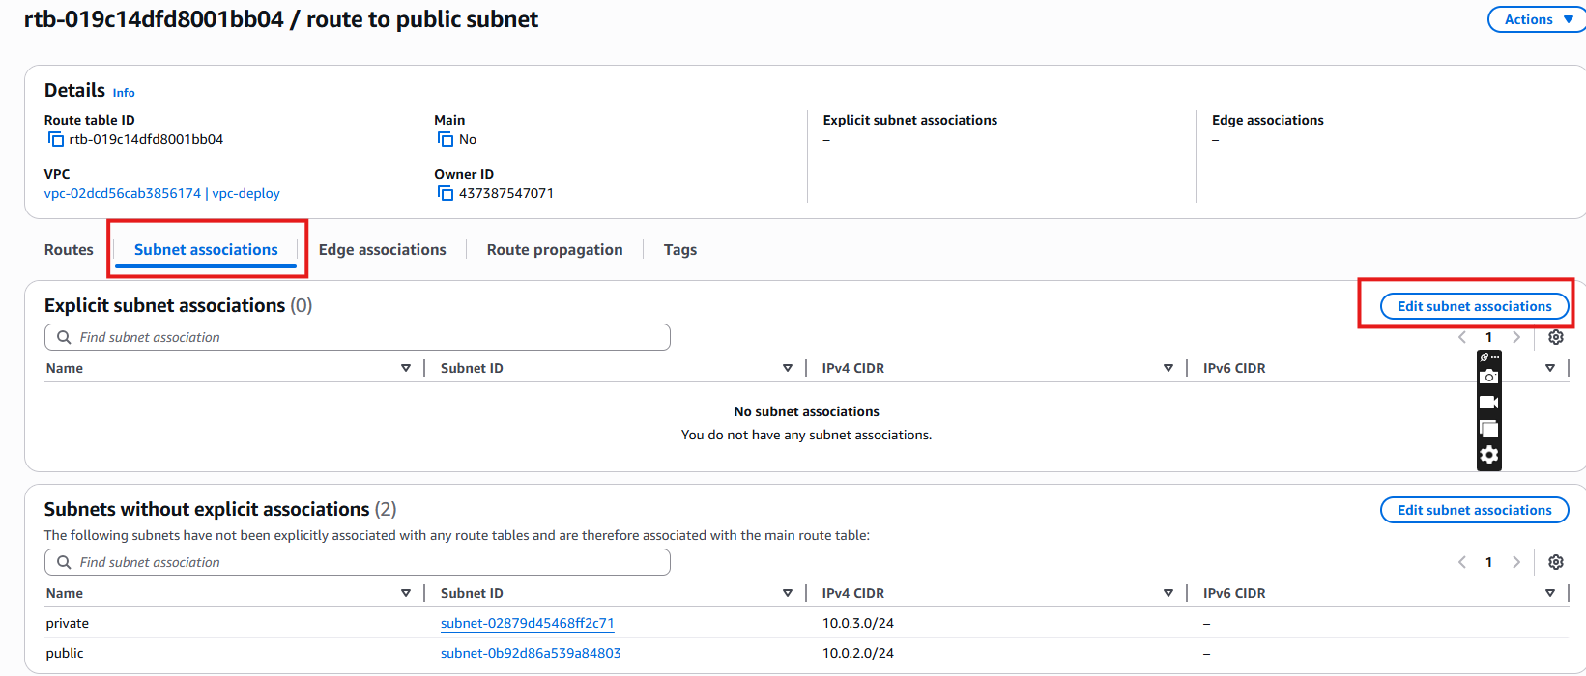

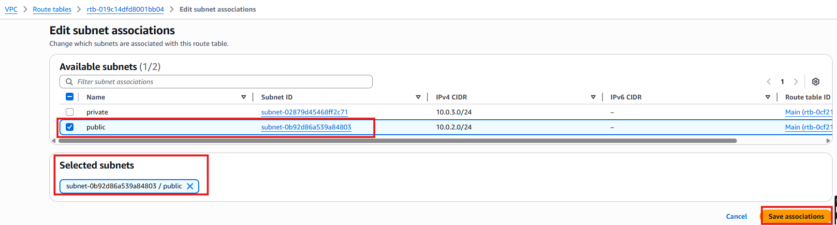

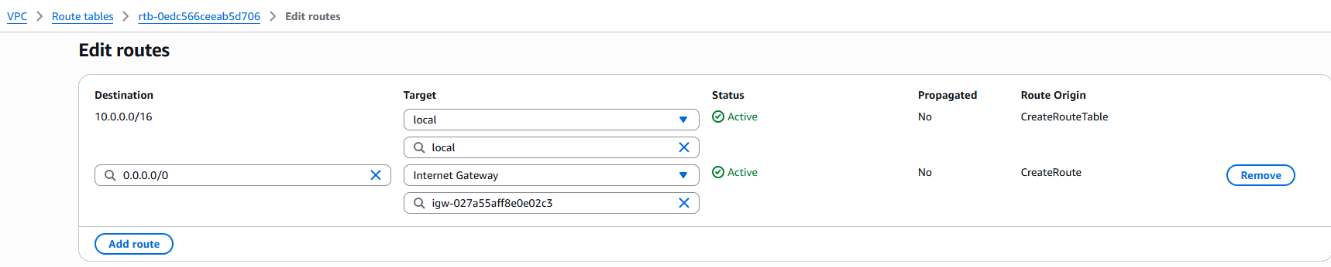

Now Create Private Route table and associated with private subnet
The instance in private subnet will not able to communicate with internet and we need to install nodejs, npm and mariadb for this we need internet
Private subnet need NAT Gateway to connect to internet
Configure NAT Gateway,
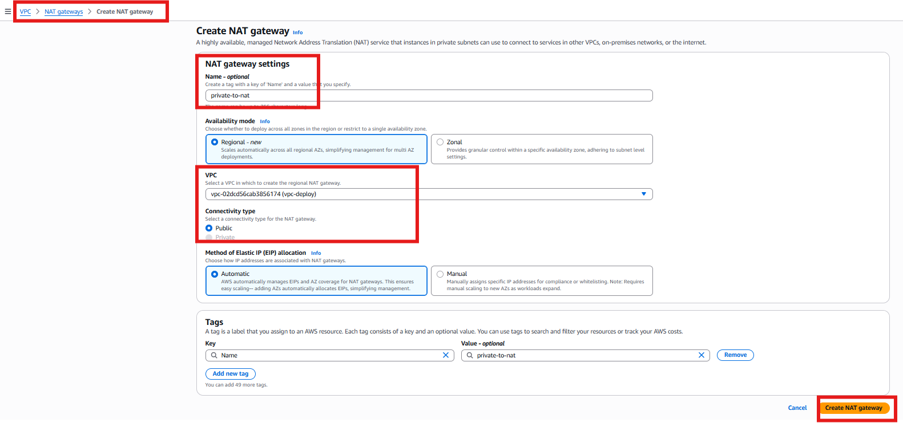
Now create Route table for Private subnet
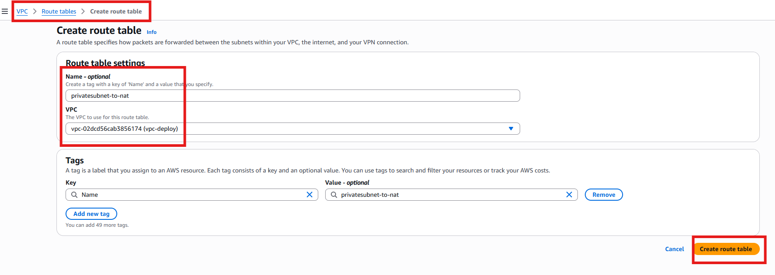
Associate this private route to private subnet
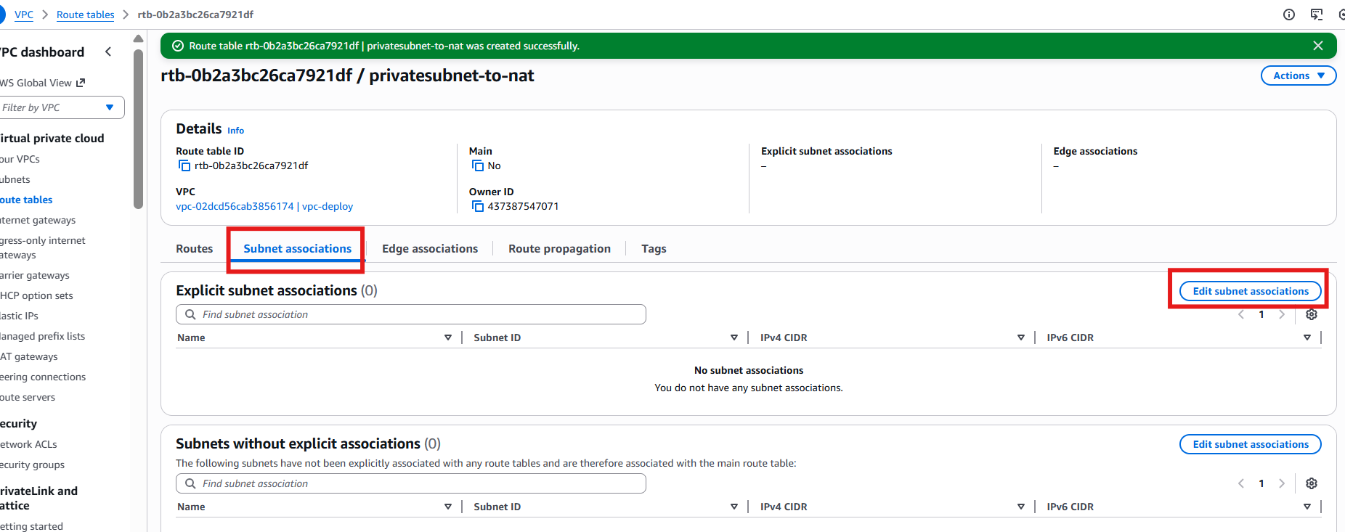
Select private and Save
Now Edit Routes
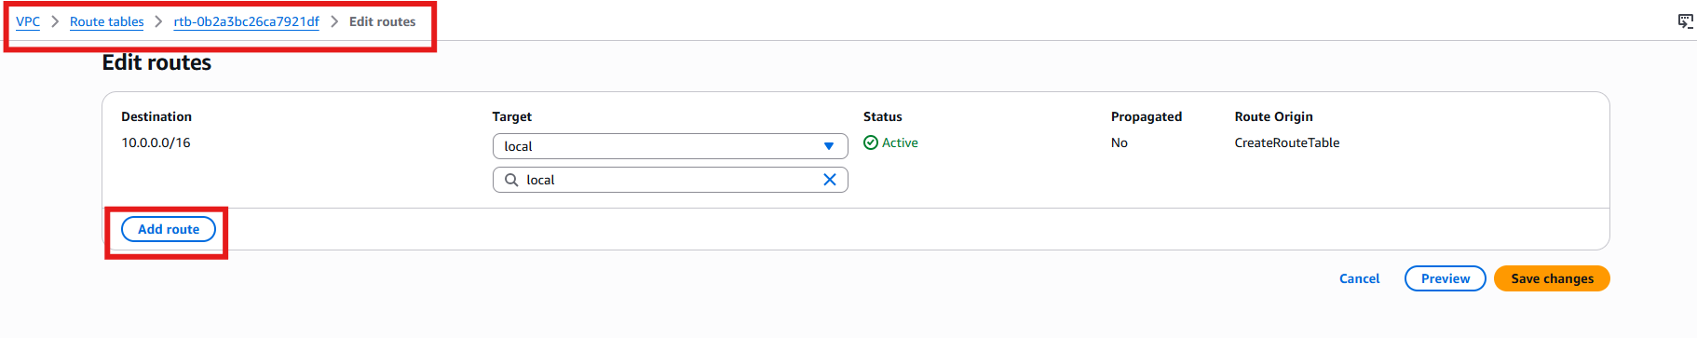

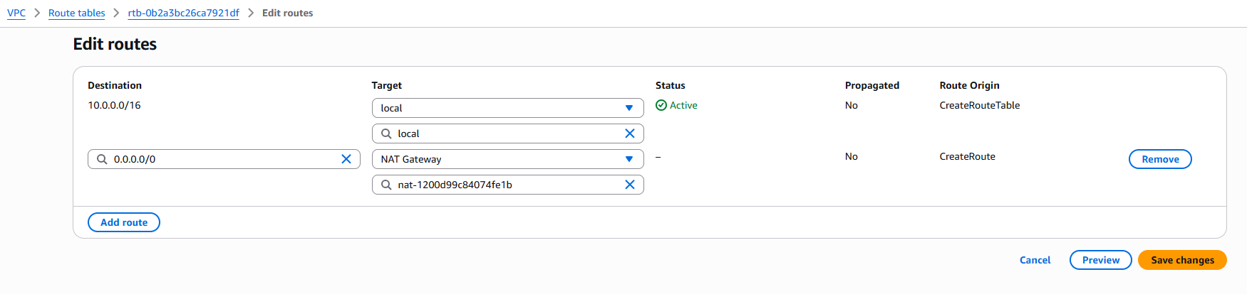
You can’t do ssh directly to app server and database server because it has private ip not public ip.
Now loging to nginx server
#apt update
#apt install nginx -y
#systemctl restart nginx
Login to app server
#ssh -i appserver.pem ubuntu@<appserver_private_ip>
#sudo -i
#apt update -y
#apt install nodejs npm -y
Project structure will be followed as:
/nodejs
|-- package.json
|-- .env
|-- server.js
|-- db.js
|-- public/
|-- index.html

#mkdir nodejs && cd nodejs
#vi package.json
{
"name": "simple-three-tier-api",
"version": "1.0.0",
"main": "server.js",
"type": "module",
"dependencies": {
"express": "^4.19.2",
"mariadb": "^3.2.0",
"dotenv": "^16.3.1"
}
}
Install npm dependencies
#npm install
#vi .env
PORT=3000-
DB_HOST=<DATABASE PRIVATE IP>
DB_USER=<DB user>
DB_PASS=<DB_PASSWORD>
DB_NAME=<DATABASE NAME>
We will create later database and add here

#vi db.js
import mariadb from "mariadb";
import dotenv from "dotenv";
dotenv.config();

export const pool = mariadb.createPool({
host: process.env.DB_HOST,
user: process.env.DB_USER,
password: process.env.DB_PASS,
database: process.env.DB_NAME,
connectionLimit: 5
});

export async function insert(sql, params) {
let conn;
try {
conn = await pool.getConnection();
return await conn.query(sql, params);
} finally {
if (conn) conn.release();
}
}

#mkdir public
#vi public/index.html
<!DOCTYPE html>
<html>
<head>
<title>Simple Webpage</title>
</head>
<body>
<h1>Welcome to the 3-Tier Application</h1>
<form id="orderForm">
<input type="text" id="name" placeholder="Customer Name" required><br><br>
<input type="text" id="item" placeholder="Item" required><br><br>
<input type="number" id="amount" placeholder="Amount" required><br><br>
<button type="submit">Add Order</button>
</form>

<p id="message"></p>

<script>
document.getElementById("orderForm").addEventListener("submit", async (event) => {
event.preventDefault();

const data = {
customer_name: document.getElementById("name").value,
item: document.getElementById("item").value,
amount: parseFloat(document.getElementById("amount").value)
};

const res = await fetch("/add-order", {
method: "POST",
headers: { "Content-Type": "application/json" },
body: JSON.stringify(data)
});

const result = await res.json();
document.getElementById("message").innerText = result.message || result.error;
});
</script>
</body>
</html>

#vi server.js
import express from "express";
import { insert } from "./db.js";
import dotenv from "dotenv";
dotenv.config();

const app = express();
app.use(express.json());

// ▶ Serve webpage from /public
app.use(express.static("public"));

// ▶ API: Insert Order
app.post("/add-order", async (req, res) => {
const { customer_name, item, amount } = req.body;

try {
const result = await insert(
"INSERT INTO orders (customer_name, item, amount) VALUES (?, ?, ?)",
[customer_name, item, amount]
);

res.json({
success: true,
message: "Order inserted successfully!",
id: result.insertId
});

} catch (error) {
res.status(500).json({ error: "Database error", details: error.message });
}
});

app.listen(process.env.PORT, () => {
console.log(`Node API running on port ${process.env.PORT}`);
});
Login to Database server from nginx server
#ssh -i dbserver.pem ubuntu@<db_private_ip>
#sudo -i
#apt update -y
#apt install mariadb* -y
#systemctl restart mariadb
#mysql -u root -p
Will ask for password , enter directly
MariaDB [(none)]> create database appdb;
MariaDB [(none)]> CREATE USER 'appuser'@'%' IDENTIFIED BY 'P@ssword123';
MariaDB [(none)]> GRANT ALL PRIVILEGES ON appdb.* TO 'appuser'@'%';
MariaDB [(none)]> USE appdb;

CREATE TABLE orders (
id INT AUTO_INCREMENT PRIMARY KEY,
customer_name VARCHAR(100),
item VARCHAR(100),
amount DECIMAL(10,2),
created_at TIMESTAMP DEFAULT CURRENT_TIMESTAMP
);

MariaDB [appdb]> flush privileges;
#
# vi /etc/mysql/mariadb.conf.d/50-server.cnf
Change bind address from 127.0.0.1 to bind-address = 0.0.0.0
# systemctl restart mariadb
# systemctl status mariadb
In Application server .env add database server private ip, username, password, database name which we created in mysql server
#vi .env
PORT=3000
DB_HOST=172.31.79.9
DB_USER=appuser
DB_PASS=P@ssword123
DB_NAME=appdb
Now start application server
#npm start &
OR
#node server.js
Step 6.
Login to nginx server
#sudo -i
#apt update -y
#apt install nginx -y
# # vi /etc/nginx/sites-available/nodeapp.conf
server {
listen 80;
server_name _;

location / {
proxy_pass http:// 10.0.3.223:3000; # Node.js server private IP

proxy_http_version 1.1;
proxy_set_header Upgrade $http_upgrade;
proxy_set_header Connection 'upgrade';
proxy_set_header Host $host;
proxy_cache_bypass $http_upgrade;

proxy_read_timeout 300;
proxy_connect_timeout 300;
}
}
# ln -s /etc/nginx/sites-available/nodeapp.conf /etc/nginx/sites-enabled/
# systemctl restart nginx

Now check with nginx server IP

